Dishes and their allergen content
Week 1
Dishes | 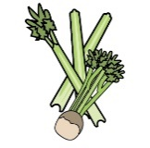 | 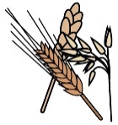 | 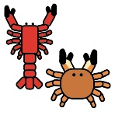 | 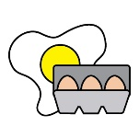 | 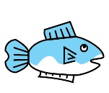 | 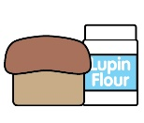 | 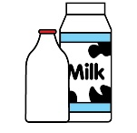 |  | 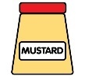 | 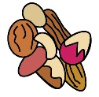 | 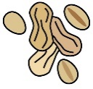 | 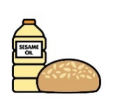 |  | 
Monday | Celery | Cereals containing gluten* | Crustaceans | Eggs | Fish | Lupin | Milk | Mollusc | Mustard | Nuts† | Peanuts | Sesame seeds | Soya | Sulphur Dioxide
Chicken salad wrap |  | ✓ |  | ✓ |  |  |  |  | ✓
Veggie nugget salad wrap |  | ✓ |  | ✓ |  |  |  |  | ✓
Veggie pasta |  | ✓
Belgian waffle and fruit |  | ✓ |  | ✓ |  |  | ✓ |  |  |  |  |  | ✓
Yoghurt |  |  |  |  |  |  | ✓
Fruit
GF/DF:Chicken salad wrap |  |  |  | ✓ |  |  |  |  | ✓
GF/DF:Sponge cake and fruity jam
Vegan:Veggie nugget wrap |  | ✓
Vegan:Sponge cake and fruity jam
Jacket and cheese |  |  |  |  |  |  | ✓
New potatoes
Vegetables
Salad for wraps | ✓
Mayo for wraps |  |  |  | ✓ |  |  |  |  | ✓
Cheese for jackets |  |  |  |  |  |  | ✓
Wraps |  | ✓
Bread |  | ✓
Packed lunches |  | ✓ |  | ✓ |  |  | ✓ |  | ✓ |  |  | ✓
Checklist
Cold meal boxes | ✓ | ✓ |  | ✓ | ✓ |  | ✓ |  | ✓ |  |  | ✓ | ✓

Dishes
Tuesday | Celery | Cereals containing gluten* | Crustaceans | Eggs | Fish | Lupin | Milk | Mollusc | Mustard | Nuts† | Peanuts | Sesame seeds | Soya | Sulphur Dioxide
Beef burrito wrap |  | ✓
Veggie burrito wrap |  | ✓
Veggie pasta |  | ✓
Apple crumble cake |  | ✓ |  | ✓ |  |  | ✓ |  |  |  |  |  | ✓
Yoghurt |  |  |  |  |  |  | ✓
Fruit
GF/DF:Beef burrito wrap
GF/DF:Apple cake
Vegan:Lentil burrito wrap |  | ✓
Vegan:Apple cake
Jacket and beans
Rice
Vegetables
Salad | ✓
Beans for jackets
Wrap for burrito |  | ✓
Bread |  | ✓
Packed lunches |  | ✓ |  | ✓ |  |  | ✓ |  | ✓ |  |  | ✓
Checklist
Cold meal boxes | ✓ | ✓ |  | ✓ | ✓ |  | ✓ |  | ✓ |  |  | ✓ | ✓

Dishes
Wednesday | Celery | Cereals containing gluten* | Crustaceans | Eggs | Fish | Lupin | Milk | Mollusc | Mustard | Nuts† | Peanuts | Sesame seeds | Soya | Sulphur Dioxide
Sausage roast dinner |  | ✓ |  |  |  |  |  |  |  |  |  |  | ✓ | ✓
Quorn sausage |  | ✓
Veggie pasta |  | ✓
Cranberry raisin flapjack |  | ✓ |  |  |  |  | ✓ |  |  |  |  |  |  | ✓
Yoghurt |  |  |  |  |  |  | ✓
Fruit
GF/DF:Roast sausage |  |  |  |  |  |  |  |  |  |  |  |  |  | ✓
GF/DF:Fruity cookie |  |  |  |  |  |  |  |  |  |  |  |  |  | ✓
Vegan:Quorn sausage |  | ✓
Vegan:Fruity cookie |  |  |  |  |  |  |  |  |  |  |  |  |  | ✓
Jacket Tuna |  |  |  | ✓ | ✓ |  |  |  | ✓
Roast potatoes
Vegetables
Tuna for jackets |  |  |  | ✓ | ✓ |  |  |  | ✓
Yorkshire |  | ✓ |  | ✓ |  |  | ✓
Gravy
Gluten free/Vegan Yorkshire |  |  |  |  |  |  |  |  |  |  |  |  | ✓
Bread |  | ✓
Packed lunches |  | ✓ |  | ✓ |  |  | ✓ |  | ✓ |  |  | ✓
Checklist
Cold meal boxes | ✓ | ✓ |  | ✓ | ✓ |  | ✓ |  | ✓ |  |  | ✓ | ✓

Dishes
Thursday | Celery | Cereals containing gluten* | Crustaceans | Eggs | Fish | Lupin | Milk | Mollusc | Mustard | Nuts† | Peanuts | Sesame seeds | Soya | Sulphur Dioxide
Mild chicken korma |  |  |  |  |  |  | ✓
Mild veggie curry |  |  |  |  |  |  | ✓
Veggie pasta |  | ✓
Rich chocolate cake |  | ✓ |  | ✓ |  |  | ✓
Yoghurt |  |  |  |  |  |  | ✓
Fruit
GF/DF:Mild chicken korma
GF/DF:Chocolate sponge
Vegan:Mild veggie curry
Vegan:Chocolate sponge
Jacket and cheese |  |  |  |  |  |  | ✓
Rice
Salad | ✓
Vegetables
Bread |  | ✓
Packed lunches |  | ✓ |  | ✓ |  |  | ✓ |  | ✓ |  |  | ✓
Checklist
Cold meal boxes | ✓ | ✓ |  | ✓ | ✓ |  | ✓ |  | ✓ |  |  | ✓ | ✓

Dishes
Friday | Celery | Cereals containing gluten* | Crustaceans | Eggs | Fish | Lupin | Milk | Mollusc | Mustard | Nuts† | Peanuts | Sesame seeds | Soya | Sulphur Dioxide
MSC battered fish |  | ✓ |  |  | ✓
Salmon fishcake |  | ✓ |  |  | ✓
Cheese and tomato pizza |  | ✓ |  |  |  |  | ✓
Veggie pasta |  | ✓
Ice cream and fruit |  |  |  |  |  |  | ✓
Yoghurt |  |  |  |  |  |  | ✓
Fruit
GF/DF:MSC battered fish |  |  |  |  | ✓
Gf/DF:Ice lolly
Vegan:Vegetable burger |  | ✓
Vegan:Ice lolly
Jacket and beans
Chips
Salad | ✓
Beans
Ketchup | ✓
Bread |  | ✓
Packed lunches |  | ✓ |  | ✓ |  |  | ✓ |  | ✓ |  |  | ✓
Checklist
Cold meal boxes | ✓ | ✓ |  | ✓ | ✓ |  | ✓ |  | ✓ |  |  | ✓ | ✓

Review date: | 23.03.2025 | Reviewed by: | J Honess |  | 

