Dishes and their allergen content
Week 2
Dishes | 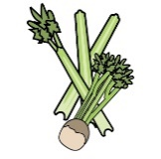 | 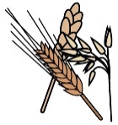 | 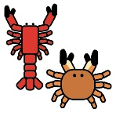 | 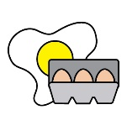 | 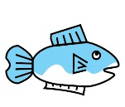 | 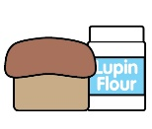 | 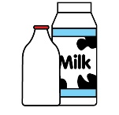 |  | 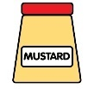 | 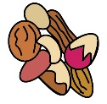 | 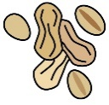 | 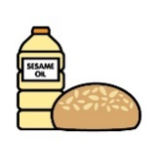 |  | 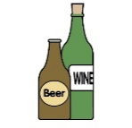
Monday | Celery | Cereals containing gluten* | Crustaceans | Eggs | Fish | Lupin | Milk | Mollusc | Mustard | Nuts† | Peanuts | Sesame seeds | Soya | Sulphur Dioxide
Meatball melt | ✓ | ✓ |  | ✓ |  |  | ✓ |  | ✓ |  |  |  | ✓ | ✓
Veggie meatball melt |  | ✓ |  |  |  |  | ✓ |  |  |  |  |  | ✓
Veggie pasta |  | ✓
Croissant and fruity jam |  | ✓ |  | ✓ |  |  | ✓ |  |  |  |  |  | ✓
Yoghurt |  |  |  |  |  |  | ✓
Fruit
GF/DF:Meatball melt |  |  |  |  |  |  |  |  |  |  |  |  | ✓
GF/DF:Chocolate pot |  |  |  |  |  |  |  |  |  |  |  |  | ✓
Vegan:Veggie meatball melt |  |  |  |  |  |  |  |  |  |  |  |  | ✓
Vegan:Chocolate pot |  |  |  |  |  |  |  |  |  |  |  |  | ✓
Jacket and cheese |  |  |  |  |  |  | ✓
Pasta |  | ✓
Vegetables
Salad | ✓
Cheese for jackets |  |  |  |  |  |  | ✓
Bread |  | ✓
Packed lunches |  | ✓ |  | ✓ |  |  | ✓ |  | ✓ |  |  | ✓
Checklist
Cold meal boxes | ✓ | ✓ |  | ✓ | ✓ |  | ✓ |  | ✓ |  |  | ✓ | ✓

Dishes
Tuesday | Celery | Cereals containing gluten* | Crustaceans | Eggs | Fish | Lupin | Milk | Mollusc | Mustard | Nuts† | Peanuts | Sesame seeds | Soya | Sulphur Dioxide
Chicken and veg casserole | ✓ | ✓ |  |  |  |  | ✓
Quorn and veg casserole | ✓ | ✓ |  | ✓ |  |  | ✓ |  | ✓
Veggie pasta |  | ✓
Iced peach sponge |  | ✓ |  | ✓ |  |  | ✓ |  |  |  |  |  | ✓
Yoghurt |  |  |  |  |  |  | ✓
Fruit
GF/DF:Chicken casserole | ✓
GF/DF:Apple cake
Vegan:Chicken casserole | ✓ | ✓
Vegan:Apple cake
Jacket and beans
New potatoes
Vegetables
Beans for jackets
Bread |  | ✓
Packed lunches |  | ✓ |  | ✓ |  |  | ✓ |  | ✓ |  |  | ✓
Checklist
Cold meal boxes | ✓ | ✓ |  | ✓ | ✓ |  | ✓ |  | ✓ |  |  | ✓ | ✓

Dishes
Wednesday | Celery | Cereals containing gluten* | Crustaceans | Eggs | Fish | Lupin | Milk | Mollusc | Mustard | Nuts† | Peanuts | Sesame seeds | Soya | Sulphur Dioxide
Ham roast dinner
Quorn roast dinner |  |  |  | ✓ |  |  | ✓
Veggie pasta |  | ✓
Chocolate cookie |  | ✓ |  | ✓ |  |  | ✓ |  |  |  |  |  | ✓
Yoghurt |  |  |  |  |  |  | ✓
Fruit
GF/DF:Ham roast dinner
GF/DF:Chocolate cookie
Vegan:Lentil veggie bake |  | ✓
Vegan:Chocolate cookie
Jacket tuna |  |  |  | ✓ | ✓ |  |  |  | ✓
Roast potatoes
Vegetables
Tuna for jackets |  |  |  | ✓ | ✓ |  |  |  | ✓
Yorkshire |  | ✓ |  | ✓ |  |  | ✓
Gravy
Gluten free/Vegan Yorkshire |  |  |  |  |  |  |  |  |  |  |  |  | ✓
Bread |  | ✓
Packed lunches |  | ✓ |  | ✓ |  |  | ✓ |  | ✓ |  |  | ✓
Checklist
Cold meal boxes | ✓ | ✓ |  | ✓ | ✓ |  | ✓ |  | ✓ |  |  | ✓ | ✓

Dishes
Thursday | Celery | Cereals containing gluten* | Crustaceans | Eggs | Fish | Lupin | Milk | Mollusc | Mustard | Nuts† | Peanuts | Sesame seeds | Soya | Sulphur Dioxide
Bolognese pasta |  | ✓ |  |  |  |  | ✓
Veggie bolognese pasta |  | ✓ |  |  |  |  | ✓
Veggie pasta |  | ✓
Orange drizzle cake |  | ✓ |  | ✓ |  |  | ✓ |  |  |  |  |  | ✓ | ✓
Yoghurt |  |  |  |  |  |  | ✓
Fruit
GF/DF:Bolognese pasta
GF/DF:Lemon sponge |  |  |  |  |  |  |  |  |  |  |  |  |  | ✓
Vegan:Veggie bolognese pasta |  | ✓
Vegan:Lemon sponge |  |  |  |  |  |  |  |  |  |  |  |  |  | ✓
Jacket and cheese |  |  |  |  |  |  | ✓
Garlic bread |  | ✓ |  |  |  |  | ✓ |  |  |  |  |  | ✓
Salad | ✓
Vegetables
Bread |  | ✓
Packed lunches |  | ✓ |  | ✓ |  |  | ✓ |  | ✓ |  |  | ✓
Checklist
Cold meal boxes | ✓ | ✓ |  | ✓ | ✓ |  | ✓ |  | ✓ |  |  | ✓ | ✓

Dishes
Friday | Celery | Cereals containing gluten* | Crustaceans | Eggs | Fish | Lupin | Milk | Mollusc | Mustard | Nuts† | Peanuts | Sesame seeds | Soya | Sulphur Dioxide
Fish fingers |  | ✓ |  |  | ✓
Cheese and tomato pizza |  | ✓ |  |  |  |  | ✓
Veggie pasta |  | ✓
Ice cream and fruit |  |  |  |  |  |  | ✓
Yoghurt |  |  |  |  |  |  | ✓
Fruit
GF/DF:Fish fingers |  |  |  |  | ✓
Gf/DF:Ice lolly
Vegan:Fishless fingers |  | ✓
Vegan:Ice lolly
Jacket and beans
Chips
Salad | ✓
Beans
Ketchup | ✓
Bread |  | ✓
Packed lunches |  | ✓ |  | ✓ |  |  | ✓ |  | ✓ |  |  | ✓
Checklist
Cold meal boxes | ✓ | ✓ |  | ✓ | ✓ |  | ✓ |  | ✓ |  |  | ✓ | ✓

Review date: | 23.03.2025 | Reviewed by: | J Honess |  | 

