Dishes and their allergen content
Week 4
Dishes | 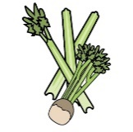 | 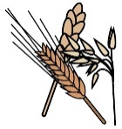 | 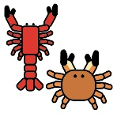 | 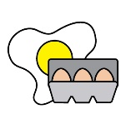 | 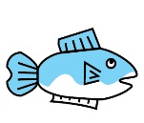 | 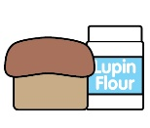 | 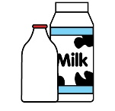 |  | 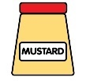 | 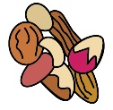 | 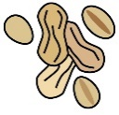 | 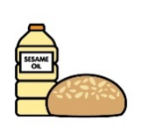 |  | 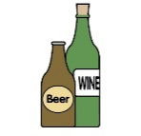
Monday | Celery | Cereals containing gluten* | Crustaceans | Eggs | Fish | Lupin | Milk | Mollusc | Mustard | Nuts† | Peanuts | Sesame seeds | Soya | Sulphur Dioxide
Cheesy meatball bake | ✓ | ✓ |  | ✓ |  |  | ✓ |  | ✓ |  |  |  | ✓ | ✓
Cheesy veggie meatball bake |  | ✓ |  |  |  |  | ✓ |  |  |  |  |  | ✓
Veggie pasta |  | ✓
Croissant and jam |  | ✓ |  |  |  |  | ✓ |  |  |  |  |  | ✓ | ✓
Yoghurt |  |  |  |  |  |  | ✓
Fruit
GF/DF:Cheesy meatball bake |  |  |  |  |  |  |  |  |  |  |  |  | ✓
GF/DF:Sponge cake |  |  |  |  |  |  |  |  |  |  |  |  | ✓
GF/DF:Veggie pasta
Vegan:Cheesy veg meatballs |  |  |  |  |  |  |  |  |  |  |  |  | ✓
Vegan:Sponge cake |  |  |  |  |  |  |  |  |  |  |  |  | ✓
Jacket and cheese |  |  |  |  |  |  | ✓
Pasta |  | ✓
Vegetables
Salad for wraps | ✓
Cheese for jackets |  |  |  |  |  |  | ✓
Bread |  | ✓
Packed lunches |  | ✓ |  | ✓ |  |  | ✓ |  | ✓ |  |  | ✓
Checklist
Cold meal boxes | ✓ | ✓ |  | ✓ | ✓ |  | ✓ |  | ✓ |  |  | ✓ | ✓

Dishes
Tuesday | Celery | Cereals containing gluten* | Crustaceans | Eggs | Fish | Lupin | Milk | Mollusc | Mustard | Nuts† | Peanuts | Sesame seeds | Soya | Sulphur Dioxide
Beef burrito wrap |  | ✓ |  |  |  |  | ✓ |  | ✓
Veggie burrito wrap |  | ✓ |  |  |  |  | ✓ |  | ✓
Veggie pasta |  | ✓
Peach sponge cake |  | ✓ |  | ✓ |  |  | ✓ |  |  |  |  |  | ✓ | ✓
Yoghurt |  |  |  |  |  |  | ✓
Fruit
GF/DF:Mild beef chilli & nachos |  |  |  |  |  |  |  |  | ✓
GF/DF:Fruit sponge |  |  |  |  |  |  |  |  |  |  |  |  | ✓
GF/DF:Veggie pasta
Vegan:Mild veg chilli wrap |  | ✓ |  |  |  |  |  |  | ✓
Vegan:Fruit sponge |  |  |  |  |  |  |  |  |  |  |  |  | ✓
Jacket and beans
Vegetables
Salad | ✓
Beans for jackets
Wraps |  | ✓
Bread |  | ✓
Packed lunches |  | ✓ |  | ✓ |  |  | ✓ |  | ✓ |  |  | ✓
Checklist
Cold meal boxes | ✓ | ✓ |  | ✓ | ✓ |  | ✓ |  | ✓ |  |  | ✓ | ✓

Dishes
Wednesday | Celery | Cereals containing gluten* | Crustaceans | Eggs | Fish | Lupin | Milk | Mollusc | Mustard | Nuts† | Peanuts | Sesame seeds | Soya | Sulphur Dioxide
Roast chicken
Lentil bake |  | ✓ |  |  |  |  | ✓
Veggie pasta |  | ✓
Oaty apple crumble slice |  | ✓ |  | ✓ |  |  | ✓ |  |  |  |  |  | ✓ | ✓
Yoghurt |  |  |  |  |  |  | ✓
Fruit
GF/DF:Roast chicken
GF/DF:Chocolate pot |  |  |  |  |  |  |  |  |  |  |  |  | ✓
GF/DF:Veggie pasta
Vegan:Lentil bake |  | ✓
Vegan:Chocolate pot |  |  |  |  |  |  |  |  |  |  |  |  | ✓
Jacket Tuna |  |  |  | ✓ | ✓ |  |  |  | ✓
Roast potatoes
Vegetables
Tuna for jackets |  |  |  | ✓ | ✓ |  |  |  | ✓
Yorkshire pudding |  | ✓ |  | ✓ |  |  | ✓
Gravy
Gluten free/Vegan Yorkshire |  |  |  |  |  |  |  |  |  |  |  |  | ✓
Bread |  | ✓
Packed lunches |  | ✓ |  | ✓ |  |  | ✓ |  | ✓ |  |  | ✓
Checklist
Cold meal boxes | ✓ | ✓ |  | ✓ | ✓ |  | ✓ |  | ✓ |  |  | ✓ | ✓

Dishes
Thursday | Celery | Cereals containing gluten* | Crustaceans | Eggs | Fish | Lupin | Milk | Mollusc | Mustard | Nuts† | Peanuts | Sesame seeds | Soya | Sulphur Dioxide
Beef bolognese pasta |  | ✓
Veggie bolognese pasta |  | ✓
Veggie pasta |  | ✓
Orange drizzle cake |  | ✓ |  | ✓ |  |  | ✓ |  |  |  |  |  | ✓ | ✓
Yoghurt |  |  |  |  |  |  | ✓
Fruit
GF/DF:Beef bolognese
GF/DF:Chocolate pot |  |  |  |  |  |  |  |  |  |  |  |  | ✓
GF/DF:Veggie pasta
Vegan:Veggie bolognese |  | ✓
Vegan:Chocolate pot |  |  |  |  |  |  |  |  |  |  |  |  | ✓
Jacket and cheese |  |  |  |  |  |  | ✓
Garlic bread |  | ✓ |  |  |  |  | ✓ |  |  |  |  |  | ✓
Salad | ✓
Vegetables |  | ✓
Bread |  | ✓ |  | ✓ |  |  | ✓ |  | ✓ |  |  | ✓
Packed lunches
Checklist | ✓ | ✓ |  | ✓ | ✓ |  | ✓ |  | ✓ |  |  | ✓ | ✓
Cold meal boxes

Dishes
Friday | Celery | Cereals containing gluten* | Crustaceans | Eggs | Fish | Lupin | Milk | Mollusc | Mustard | Nuts† | Peanuts | Sesame seeds | Soya | Sulphur Dioxide
Fishcake |  | ✓ |  |  | ✓
Salmon fishcake |  | ✓ |  |  | ✓
Cheese and tomato pizza |  | ✓ |  |  |  |  | ✓
Veggie pasta |  | ✓
Ice cream and fruit |  |  |  |  |  |  | ✓
Yoghurt |  |  |  |  |  |  | ✓
Fruit
GF/DF:Cheese tomato pizza |  |  |  |  |  |  |  |  | ✓ |  |  |  | ✓
Gf/DF:Ice lolly
GF/DF:Veggie pasta
Vegan:Cheese tomato pizza |  |  |  |  |  |  |  |  | ✓ |  |  |  | ✓
Vegan:Ice lolly
Jacket and beans
Chips
Salad | ✓
Beans
Ketchup | ✓
Bread |  | ✓
Packed lunches |  | ✓ |  | ✓ |  |  | ✓ |  | ✓ |  |  | ✓
Checklist
Cold meal boxes | ✓ | ✓ |  | ✓ | ✓ |  | ✓ |  | ✓ |  |  | ✓ | ✓

Review date: | 208.07.2026 | Reviewed by: | J Honess |  | 

