Dishes and their allergen content
Week 1
Dishes | 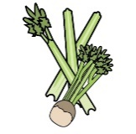 | 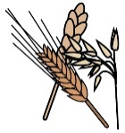 | 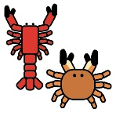 | 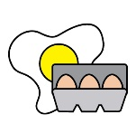 | 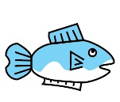 | 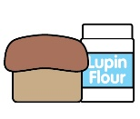 | 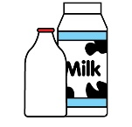 |  | 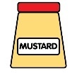 | 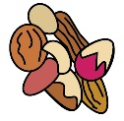 | 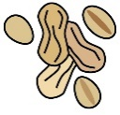 | 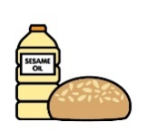 |  | 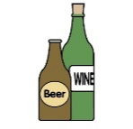
Monday | Celery | Cereals containing gluten* | Crustaceans | Eggs | Fish | Lupin | Milk | Mollusc | Mustard | Nuts† | Peanuts | Sesame seeds | Soya | Sulphur Dioxide
Chicken salad wrap |  | ✓ |  | ✓ |  |  |  |  | ✓
Veggie nugget salad wrap |  | ✓ |  | ✓ |  |  |  |  | ✓
Veggie pasta |  | ✓
Fruity crunch cookie |  | ✓ |  | ✓ |  |  | ✓ |  |  |  |  |  | ✓ | ✓
Yoghurt |  |  |  |  |  |  | ✓
Fruit
GF/DF:Chicken salad wrap |  |  |  | ✓ |  |  |  |  | ✓
GF/DF:Sponge cake |  |  |  |  |  |  |  |  |  |  |  |  | ✓
GF/DF:Veggie pasta
Vegan:Veggie nugget wrap |  | ✓
Vegan:Sponge cake |  |  |  |  |  |  |  |  |  |  |  |  | ✓
Jacket and cheese |  |  |  |  |  |  | ✓
New potatoes
Vegetables
Salad for wraps | ✓
Mayo for wraps |  |  |  | ✓ |  |  |  |  | ✓
Cheese for jackets |  |  |  |  |  |  | ✓
Wraps |  | ✓
Bread |  | ✓
Packed lunches |  | ✓ |  | ✓ |  |  | ✓ |  | ✓ |  |  | ✓
Checklist
Cold meal boxes | ✓ | ✓ |  | ✓ | ✓ |  | ✓ |  | ✓ |  |  | ✓ | ✓

Dishes
Tuesday | Celery | Cereals containing gluten* | Crustaceans | Eggs | Fish | Lupin | Milk | Mollusc | Mustard | Nuts† | Peanuts | Sesame seeds | Soya | Sulphur Dioxide
Creamy chicken sweetcorn pasta |  | ✓ |  |  |  |  | ✓
Veggie sweetcorn pasta |  | ✓ |  |  |  |  | ✓
Veggie pasta |  | ✓
Sticky toffee apple cake |  | ✓ |  | ✓ |  |  | ✓ |  |  |  |  |  | ✓
Yoghurt |  |  |  |  |  |  | ✓
Fruit
GF/DF:Chicken sweetcorn pasta
GF/DF:Apple cake |  |  |  |  |  |  |  |  |  |  |  |  | ✓
GF/DF:Veggie pasta
Vegan:Veggie sweetcorn pasta |  | ✓
Vegan:Apple cake |  |  |  |  |  |  |  |  |  |  |  |  | ✓
Jacket and beans
Garlic bread |  | ✓ |  |  |  |  | ✓ |  |  |  |  |  | ✓
Vegetables
Salad | ✓
Beans for jackets
Bread |  | ✓
Packed lunches |  | ✓ |  | ✓ |  |  | ✓ |  | ✓ |  |  | ✓
Checklist
Cold meal boxes | ✓ | ✓ |  | ✓ | ✓ |  | ✓ |  | ✓ |  |  | ✓ | ✓

Dishes
Wednesday | Celery | Cereals containing gluten* | Crustaceans | Eggs | Fish | Lupin | Milk | Mollusc | Mustard | Nuts† | Peanuts | Sesame seeds | Soya | Sulphur Dioxide
Chicken and veg pie |  | ✓
Quorn sausage |  | ✓
Veggie pasta |  | ✓
Apple and berry sponge |  | ✓ |  | ✓ |  |  | ✓ |  |  |  |  |  | ✓ | ✓
Yoghurt |  |  |  |  |  |  | ✓
Fruit
GF/DF:Roast chicken
GF/DF:Fruity sponge |  |  |  |  |  |  |  |  |  |  |  |  | ✓
GF/DF:Veggie pasta
Vegan:Quorn sausage |  | ✓
Vegan:Fruity sponge |  |  |  |  |  |  |  |  |  |  |  |  | ✓
Jacket Tuna |  |  |  | ✓ | ✓ |  |  |  | ✓
Roast potatoes
Vegetables
Tuna for jackets |  |  |  | ✓ | ✓ |  |  |  | ✓
Pie lid |  | ✓
Gravy
Gluten free/Vegan Yorkshire |  |  |  |  |  |  |  |  |  |  |  |  | ✓
Bread |  | ✓
Packed lunches |  | ✓ |  | ✓ |  |  | ✓ |  | ✓ |  |  | ✓
Checklist
Cold meal boxes | ✓ | ✓ |  | ✓ | ✓ |  | ✓ |  | ✓ |  |  | ✓ | ✓

Dishes
Thursday | Celery | Cereals containing gluten* | Crustaceans | Eggs | Fish | Lupin | Milk | Mollusc | Mustard | Nuts† | Peanuts | Sesame seeds | Soya | Sulphur Dioxide
BBQ chicken and rice wrap |  | ✓ |  |  |  |  |  |  | ✓
BBQ bean and cheese rice wrap |  | ✓ |  |  |  |  |  |  | ✓
Veggie pasta |  | ✓
Chocolate brownie slice |  | ✓ |  | ✓ |  |  | ✓ |  |  |  |  |  | ✓
Yoghurt |  |  |  |  |  |  | ✓
Fruit
GF/DF:BBQ chicken rice |  |  |  |  |  |  |  |  | ✓
GF/DF:Chocolate cake |  |  |  |  |  |  |  |  |  |  |  |  | ✓
GF/DF:Veggie pasta
Vegan:BBQ veggie rice wrap |  |  |  |  |  |  |  |  | ✓
Vegan:Chocolate cake |  |  |  |  |  |  |  |  |  |  |  |  | ✓
Jacket and cheese |  |  |  |  |  |  | ✓
Salad | ✓
Vegetables
Wraps |  | ✓
Bread |  | ✓
Packed lunches |  | ✓ |  | ✓ |  |  | ✓ |  | ✓ |  |  | ✓
Checklist
Cold meal boxes | ✓ | ✓ |  | ✓ | ✓ |  | ✓ |  | ✓ |  |  | ✓ | ✓

Dishes
Friday | Celery | Cereals containing gluten* | Crustaceans | Eggs | Fish | Lupin | Milk | Mollusc | Mustard | Nuts† | Peanuts | Sesame seeds | Soya | Sulphur Dioxide
MSC fish fingers |  | ✓ |  |  | ✓
Salmon fishcake |  | ✓ |  |  | ✓
Cheese and tomato pizza |  | ✓ |  |  |  |  | ✓
Veggie pasta |  | ✓
Ice cream and fruit |  |  |  |  |  |  | ✓
Yoghurt |  |  |  |  |  |  | ✓
Fruit
GF/DF:Fish fingers |  |  |  |  | ✓
Gf/DF:Ice lolly
GF/DF:Veggie pasta
Vegan:Fishless fingers |  | ✓
Vegan:Ice lolly
Jacket and beans
Chips
Salad | ✓
Beans
Ketchup | ✓
Bread |  | ✓
Packed lunches |  | ✓ |  | ✓ |  |  | ✓ |  | ✓ |  |  | ✓
Checklist
Cold meal boxes | ✓ | ✓ |  | ✓ | ✓ |  | ✓ |  | ✓ |  |  | ✓ | ✓

Review date: | 08.07.2026 | Reviewed by: | J Honess |  | 

