Dishes and their allergen content
Week 2
Dishes | 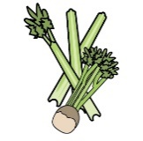 | 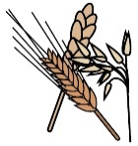 | 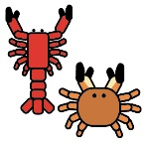 | 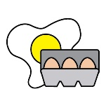 | 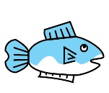 | 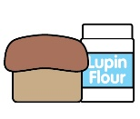 | 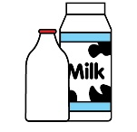 |  | 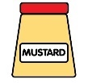 | 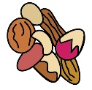 | 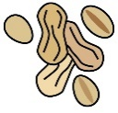 | 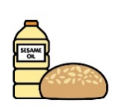 |  | 
Monday | Celery | Cereals containing gluten* | Crustaceans | Eggs | Fish | Lupin | Milk | Mollusc | Mustard | Nuts† | Peanuts | Sesame seeds | Soya | Sulphur Dioxide
Mozzarella meatball melt | ✓ | ✓ |  | ✓ |  |  | ✓ |  | ✓ |  |  |  | ✓ | ✓
Mozzarella no-meatball melt |  |  |  |  |  |  | ✓ |  |  |  |  |  | ✓
Jam doughnut |  | ✓ |  | ✓ |  |  | ✓ |  |  |  |  |  | ✓ | ✓
Yoghurt |  |  |  |  |  |  | ✓
Fruit
GF/DF:Mozzarella meatball melt |  |  |  |  |  |  |  |  |  |  |  |  | ✓
GF/DF:Chocolate pot |  |  |  |  |  |  |  |  |  |  |  |  | ✓
Vegan:Mozz no-meatball melt |  | ✓ |  |  |  |  |  |  |  |  |  |  | ✓
Vegan:Chocolate pot |  |  |  |  |  |  |  |  |  |  |  |  | ✓
Jacket and cheese |  |  |  |  |  |  | ✓
Pasta |  | ✓
Salad | ✓
Vegetables
Cheese for jackets |  |  |  |  |  |  | ✓
Bread |  | ✓
Packed lunches |  | ✓ |  | ✓ |  |  | ✓ |  | ✓ |  |  | ✓
Cold meal boxes | ✓ | ✓ |  | ✓ |  |  | ✓ |  | ✓ |  |  | ✓ | ✓

Dishes
Tuesday | Celery | Cereals containing gluten* | Crustaceans | Eggs | Fish | Lupin | Milk | Mollusc | Mustard | Nuts† | Peanuts | Sesame seeds | Soya | Sulphur Dioxide
Bolognese pasta |  | ✓ |  |  |  |  | ✓ |  | ✓ |  |  |  | ✓
Veggie bolognese pasta |  | ✓ |  |  |  |  | ✓ |  | ✓ |  |  |  | ✓
Toffee apple cake |  | ✓ |  | ✓ |  |  | ✓ |  |  |  |  |  | ✓
Yoghurt |  |  |  |  |  |  | ✓
Fruit
GF/DF:Bolognese pasta
GF/DF:Chocolate cookie
Vegan:Veg bolognese pasta |  | ✓
Vegan:Chocolate cookie
Jacket and beans
Wholewheat pasta |  | ✓
Vegetables
Beans for jackets
Cheese to sprinkle on bolognese |  |  |  |  |  |  | ✓
Bread |  | ✓
Packed lunches |  | ✓ |  | ✓ |  |  | ✓ |  | ✓ |  |  | ✓
Cold meal boxes | ✓ | ✓ |  | ✓ |  |  | ✓ |  | ✓ |  |  | ✓ | ✓

Dishes
Wednesday | Celery | Cereals containing gluten* | Crustaceans | Eggs | Fish | Lupin | Milk | Mollusc | Mustard | Nuts† | Peanuts | Sesame seeds | Soya | Sulphur Dioxide
Pork loin steak
Quorn roast |  | ✓ |  | ✓ |  |  | ✓
Fruit sponge and cream |  | ✓ |  | ✓ |  |  | ✓ |  |  |  |  |  | ✓
Yoghurt |  |  |  |  |  |  | ✓
Fruit
GF/DF:Pork loin steak
GF/DF:Sponge cake
Vegan:Quorn sausage  roast |  | ✓
Vegan:Sponge cake
Jacket cheese |  |  |  |  |  |  | ✓
Roast potatoes
Vegetables
Cheese for jackets |  |  |  |  |  |  | ✓
Cream |  |  |  |  |  |  | ✓
Yorkshire |  | ✓ |  | ✓ |  |  | ✓
Gravy
Gluten free/Vegan Yorkshire |  |  |  |  |  |  |  |  |  |  |  |  | ✓
Bread |  | ✓
Packed lunches |  | ✓ |  | ✓ |  |  | ✓ |  | ✓ |  |  | ✓
Cold meal boxes | ✓ | ✓ |  | ✓ |  |  | ✓ |  | ✓ |  |  | ✓ | ✓

Dishes
Thursday | Celery | Cereals containing gluten* | Crustaceans | Eggs | Fish | Lupin | Milk | Mollusc | Mustard | Nuts† | Peanuts | Sesame seeds | Soya | Sulphur Dioxide
Mild chicken korma |  |  |  |  |  |  | ✓
Mild veg korma |  |  |  |  |  |  | ✓
Chocolate brownie |  | ✓ |  | ✓ |  |  | ✓ |  |  |  |  |  | ✓
Yoghurt |  |  |  |  |  |  | ✓
Fruit
GF/DF:Mild chicken korma
GF/DF:Chocolate cookie
Vegan:Mild veg curry
Vegan:Chocolate cookie
Jacket and cheese |  |  |  |  |  |  | ✓
Rice
Vegetables
Bread |  | ✓
Packed lunches |  | ✓ |  | ✓ |  |  | ✓ |  | ✓ |  |  | ✓
Cold meal boxes | ✓ | ✓ |  | ✓ |  |  | ✓ |  | ✓ |  |  | ✓ | ✓

Dishes
Friday | Celery | Cereals containing gluten* | Crustaceans | Eggs | Fish | Lupin | Milk | Mollusc | Mustard | Nuts† | Peanuts | Sesame seeds | Soya | Sulphur Dioxide
Beef burger |  | ✓ |  |  |  |  |  |  |  |  |  | ✓ | ✓ | ✓
Cheese and tomato pizza |  | ✓ |  |  |  |  | ✓
Ice cream and fruit |  |  |  |  |  |  | ✓
Yoghurt |  |  |  |  |  |  | ✓
Fruit
GF/DF:Beef burger |  |  |  | ✓  (in the roll)
Gf/DF:Ice lolly
Vegan:Vegetable burger |  | ✓
Vegan:Ice lolly
Jacket and beans
Chips
Salad | ✓
Beans
Ketchup | ✓
GF/DF rolls for burgers |  |  |  | ✓
Rolls for burgers |  | ✓ |  |  |  |  |  |  |  |  |  | ✓ | ✓
Bread |  | ✓
Packed lunches |  | ✓ |  | ✓ |  |  | ✓ |  | ✓ |  |  | ✓
Cold meal boxes | ✓ | ✓ |  | ✓ |  |  | ✓ |  | ✓ |  |  | ✓ | ✓

Review date: | 08.12.2025 | Reviewed by: | J Honess |  | 

