Dishes and their allergen content
Week 1
Dishes | 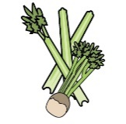 | 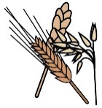 | 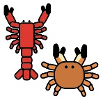 | 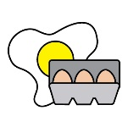 | 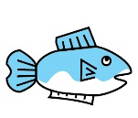 | 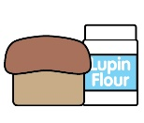 |  |  | 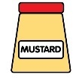 | 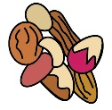 | 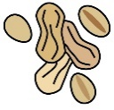 | 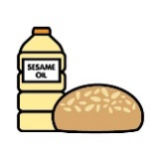 |  | 
Monday | Celery | Cereals containing gluten* | Crustaceans | Eggs | Fish | Lupin | Milk | Mollusc | Mustard | Nuts† | Peanuts | Sesame seeds | Soya | Sulphur Dioxide
Pork sausage roll |  | ✓ |  |  |  |  |  |  |  |  |  |  |  | ✓
Veggie sausage roll |  | ✓ |  |  |  |  | ✓ |  |  |  |  |  | ✓
Scone and fruity jam |  | ✓ |  | ✓ |  |  | ✓ |  |  |  |  |  | ✓
Yoghurt |  |  |  |  |  |  | ✓
Fruit
GF/DF:Pork sausage roll |  |  |  |  |  |  |  |  |  |  |  |  |  | ✓
GF/DF:Sponge cake and fruity jam
Vegan:Veggie sausage roll |  | ✓ |  |  |  |  |  |  |  |  |  |  | ✓
Vegan:Sponge cake and fruity jam
Jacket and cheese |  |  |  |  |  |  | ✓
Pasta salad |  | ✓
Vegetables
Cheese for jackets |  |  |  |  |  |  | ✓
Bread |  | ✓
Packed lunches |  | ✓ |  | ✓ |  |  | ✓ |  | ✓ |  |  | ✓
Cold meal boxes | ✓ | ✓ |  | ✓ |  |  | ✓ |  | ✓ |  |  | ✓ | ✓

Dishes
Tuesday | Celery | Cereals containing gluten* | Crustaceans | Eggs | Fish | Lupin | Milk | Mollusc | Mustard | Nuts† | Peanuts | Sesame seeds | Soya | Sulphur Dioxide
Hunter’s chicken | ✓ | ✓ |  |  |  |  |  |  | ✓ |  |  |  | ✓
Vegetable nuggets |  | ✓
Chocolate cookie |  | ✓ |  |  |  |  | ✓
Yoghurt |  |  |  |  |  |  | ✓
Fruit
GF/DF:Hunter’s chicken
GF/DF:Chocolate cookie
Vegan:Vegetable nuggets |  | ✓
Vegan:Chocolate cookie
Jacket and beans
Rice
Vegetables
Beans for jackets
Bread |  | ✓
Packed lunches |  | ✓ |  | ✓ |  |  | ✓ |  | ✓ |  |  | ✓
Cold meal boxes | ✓ | ✓ |  | ✓ |  |  | ✓ |  | ✓ |  |  | ✓ | ✓

Dishes
Wednesday | Celery | Cereals containing gluten* | Crustaceans | Eggs | Fish | Lupin | Milk | Mollusc | Mustard | Nuts† | Peanuts | Sesame seeds | Soya | Sulphur Dioxide
Sausage roast dinner |  | ✓ |  |  |  |  |  |  |  |  |  |  | ✓ | ✓
Quorn sausage |  | ✓
Iced apple cake |  | ✓ |  | ✓ |  |  | ✓
Yoghurt |  |  |  |  |  |  | ✓
Fruit
GF/DF:Roast sausage |  |  |  |  |  |  |  |  |  |  |  |  |  | ✓
GF/DF:Apple cake
Vegan:Quorn sausage |  | ✓
Vegan:Apple cake
Jacket cheese |  |  |  |  |  |  | ✓
Roast potatoes
Vegetables
Cheese for jackets |  |  |  |  |  |  | ✓
Yorkshire |  | ✓ |  | ✓ |  |  | ✓
Gravy
Gluten free/Vegan Yorkshire |  |  |  |  |  |  |  |  |  |  |  |  | ✓
Bread |  | ✓
Packed lunches |  | ✓ |  | ✓ |  |  | ✓ |  | ✓ |  |  | ✓
Cold meal boxes | ✓ | ✓ |  | ✓ |  |  | ✓ |  | ✓ |  |  | ✓ | ✓

Dishes
Thursday | Celery | Cereals containing gluten* | Crustaceans | Eggs | Fish | Lupin | Milk | Mollusc | Mustard | Nuts† | Peanuts | Sesame seeds | Soya | Sulphur Dioxide
Creamy tarragon pasta |  | ✓ |  |  |  |  | ✓ |  | ✓ |  |  |  | ✓
Vegetable burger |  | ✓
Fruity flapjack |  | ✓ |  |  |  |  | ✓ |  |  |  |  |  |  | ✓
Yoghurt |  |  |  |  |  |  | ✓
Fruit
GF/DF:Ground pork pasta
GF/DF:Fruit cookie |  |  |  |  |  |  |  |  |  |  |  |  |  | ✓
Vegan:Butter bean tomato pasta |  | ✓
Vegan:Fruit cookie |  |  |  |  |  |  |  |  |  |  |  |  |  | ✓
Jacket and cheese |  |  |  |  |  |  | ✓
Wholewheat pasta |  | ✓
Salad | ✓
Vegetables
Bread |  | ✓
Packed lunches |  | ✓ |  | ✓ |  |  | ✓ |  | ✓ |  |  | ✓
Cold meal boxes | ✓ | ✓ |  | ✓ |  |  | ✓ |  | ✓ |  |  | ✓ | ✓

Dishes
Friday | Celery | Cereals containing gluten* | Crustaceans | Eggs | Fish | Lupin | Milk | Mollusc | Mustard | Nuts† | Peanuts | Sesame seeds | Soya | Sulphur Dioxide
Fish fingers |  | ✓ |  |  | ✓
Salmon fishcake |  | ✓ |  |  | ✓
Cheese and tomato pizza |  | ✓ |  |  |  |  | ✓
Ice cream and fruit |  |  |  |  |  |  | ✓
Yoghurt |  |  |  |  |  |  | ✓
Fruit
GF/DF:Fish fingers |  |  |  |  | ✓
Gf/DF:Ice lolly
Vegan:Fishless fingers |  | ✓
Vegan:Ice lolly
Jacket and beans
Chips
Salad | ✓
Beans
Ketchup | ✓
Bread |  | ✓
Packed lunches |  | ✓ |  | ✓ |  |  | ✓ |  | ✓ |  |  | ✓
Cold meal boxes | ✓ | ✓ |  | ✓ |  |  | ✓ |  | ✓ |  |  | ✓ | ✓

Review date: | 08.12.2025 | Reviewed by: | J Honess |  | 

