Dishes and their allergen content
Week 4
Dishes | 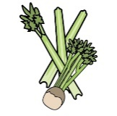 | 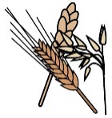 | 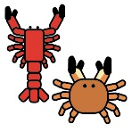 | 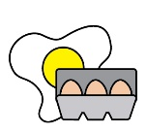 | 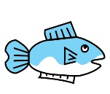 | 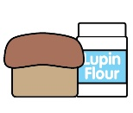 | 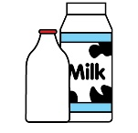 |  | 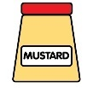 | 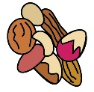 |  | 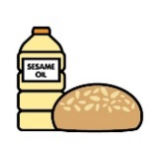 |  | 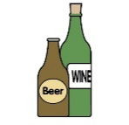
Monday | Celery | Cereals containing gluten* | Crustaceans | Eggs | Fish | Lupin | Milk | Mollusc | Mustard | Nuts† | Peanuts | Sesame seeds | Soya | Sulphur Dioxide
Chicken meatball arrabiata | ✓ | ✓ |  | ✓ |  |  | ✓ |  | ✓ |  |  |  | ✓ | ✓
Veggie meatball arrabiata |  | ✓ |  |  |  |  | ✓ |  |  |  |  |  | ✓
Veggie pasta |  | ✓
Scone and fruity jam |  | ✓ |  | ✓ |  |  | ✓ |  |  |  |  |  | ✓
Yoghurt |  |  |  |  |  |  | ✓
Fruit
GF/DF:Meatball arrabiata pasta |  |  |  |  |  |  |  |  |  |  |  |  | ✓
GF/DF:Chocolate pot |  |  |  |  |  |  |  |  |  |  |  |  | ✓
Veggie meatball arrabiata |  | ✓ |  |  |  |  |  |  |  |  |  |  | ✓
Vegan:Chocolate pot |  |  |  |  |  |  |  |  |  |  |  |  | ✓
Jacket and cheese |  |  |  |  |  |  | ✓
Pasta |  | ✓
Vegetables
Salad | ✓
Cheese for jackets |  |  |  |  |  |  | ✓
Bread |  | ✓
Packed lunches |  | ✓ |  | ✓ |  |  | ✓ |  | ✓ |  |  | ✓
Checklist
Cold meal boxes | ✓ | ✓ |  | ✓ | ✓ |  | ✓ |  | ✓ |  |  | ✓ | ✓

Dishes
Tuesday | Celery | Cereals containing gluten* | Crustaceans | Eggs | Fish | Lupin | Milk | Mollusc | Mustard | Nuts† | Peanuts | Sesame seeds | Soya | Sulphur Dioxide
Mild beef chilli |  |  |  |  |  |  | ✓
Mild veggie chilli |  |  |  |  |  |  | ✓
Veggie pasta |  | ✓
Fruity shortbread |  | ✓ |  |  |  |  | ✓ |  |  |  |  |  |  | ✓
Yoghurt |  |  |  |  |  |  | ✓
Fruit
GF/DF:Mild beef chilli
GF/DF:Fruit cookie |  |  |  |  |  |  |  |  |  |  |  |  |  | ✓
Vegan:Mild veggie chilli
Vegan:Fruit cookie |  |  |  |  |  |  |  |  |  |  |  |  |  | ✓
Jacket and beans
Rice
Vegetables
Salad | ✓
Beans for jackets
Nachos |  |  |  |  |  |  | ✓
Cheese sprinkle |  |  |  |  |  |  | ✓
Bread |  | ✓
Packed lunches |  | ✓ |  | ✓ |  |  | ✓ |  | ✓ |  |  | ✓
Checklist
Cold meal boxes | ✓ | ✓ |  | ✓ | ✓ |  | ✓ |  | ✓ |  |  | ✓ | ✓

Dishes
Wednesday | Celery | Cereals containing gluten* | Crustaceans | Eggs | Fish | Lupin | Milk | Mollusc | Mustard | Nuts† | Peanuts | Sesame seeds | Soya | Sulphur Dioxide
Sausage roast dinner |  | ✓ |  |  |  |  |  |  |  |  |  |  | ✓ | ✓
Quorn sausage roast dinner |  | ✓
Veggie pasta |  | ✓
Iced malty fruitcake |  | ✓ |  | ✓ |  |  | ✓ |  |  |  |  |  | ✓ | ✓
Yoghurt |  |  |  |  |  |  | ✓
Fruit
GF/DF:Sausage roast |  |  |  |  |  |  |  |  |  |  |  |  |  | ✓
GF/DF:Chocolate cake
Vegan:Veggie sausage roast |  | ✓
Vegan:Chocolate cake
Jacket tuna |  |  |  | ✓ | ✓ |  |  |  | ✓
Roast potatoes
Vegetables
Tuna for jackets |  |  |  | ✓ | ✓ |  |  |  | ✓
Yorkshire |  | ✓ |  | ✓ |  |  | ✓
Gravy
Gluten free/Vegan Yorkshire |  |  |  |  |  |  |  |  |  |  |  |  | ✓
Bread |  | ✓
Packed lunches |  | ✓ |  | ✓ |  |  | ✓ |  | ✓ |  |  | ✓
Checklist
Cold meal boxes | ✓ | ✓ |  | ✓ | ✓ |  | ✓ |  | ✓ |  |  | ✓ | ✓

Dishes
Thursday | Celery | Cereals containing gluten* | Crustaceans | Eggs | Fish | Lupin | Milk | Mollusc | Mustard | Nuts† | Peanuts | Sesame seeds | Soya | Sulphur Dioxide
Chicken parmigiana |  | ✓ |  |  |  |  | ✓
Veggie parmigiana |  | ✓ |  |  |  |  | ✓
Veggie pasta |  | ✓
Banana loaf cake |  | ✓ |  | ✓ |  |  | ✓ |  |  |  |  |  | ✓ | ✓
Yoghurt |  |  |  |  |  |  | ✓
Fruit
GF/DF:Chicken parmigiana pasta
GF/DF:Apple sponge
Vegan:Veggie parmigiana pasta |  | ✓
Vegan:Apple sponge
Jacket and cheese |  |  |  |  |  |  | ✓
Pasta |  | ✓
Salad | ✓
Vegetables
Bread |  | ✓
Packed lunches |  | ✓ |  | ✓ |  |  | ✓ |  | ✓ |  |  | ✓
Checklist
Cold meal boxes | ✓ | ✓ |  | ✓ | ✓ |  | ✓ |  | ✓ |  |  | ✓ | ✓

Dishes
Friday | Celery | Cereals containing gluten* | Crustaceans | Eggs | Fish | Lupin | Milk | Mollusc | Mustard | Nuts† | Peanuts | Sesame seeds | Soya | Sulphur Dioxide
Fishcake |  | ✓ |  |  | ✓
Salmon fishcake |  | ✓ |  |  | ✓
Cheese and tomato pizza |  | ✓ |  |  |  |  | ✓
Veggie pasta |  | ✓
Ice cream and fruit |  |  |  |  |  |  | ✓
Yoghurt |  |  |  |  |  |  | ✓
Fruit
GF/DF:Cheese & tomato pizza |  |  |  |  |  |  |  |  |  |  |  |  | ✓
Gf/DF:Ice lolly
Vegan:Cheese & tomato pizza |  | ✓ |  |  |  |  |  |  |  |  |  |  | ✓
Vegan:Ice lolly
Jacket and beans
Chips
Salad | ✓
Beans
Ketchup | ✓
Bread |  | ✓
Packed lunches |  | ✓ |  | ✓ |  |  | ✓ |  | ✓ |  |  | ✓
Checklist
Cold meal boxes | ✓ | ✓ |  | ✓ | ✓ |  | ✓ |  | ✓ |  |  | ✓ | ✓

Review date: | 23.03.2025 | Reviewed by: | J Honess |  | 

